Appraisal Form
Self Appraisal Form 2
Self Evaluation: 2
Projects: 5
Projects List 5
Peer Appraisal Form 6
Manager Appraisal Form 7

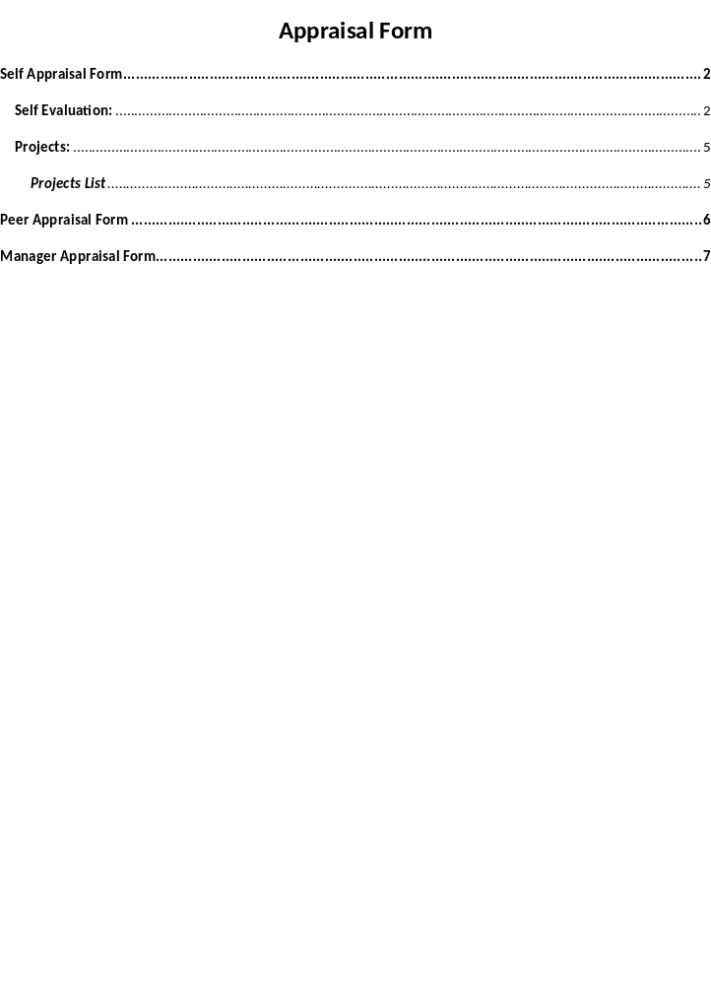
KRAs(Key Result Areas/ Target Assignments) :
As discussed in CYB\APP\APR\2014 appraisal cycle
Continue to work on the assigned project and create quality deliverables
- Enhance editing skills
- Enhance leadership skills
- Continue gaining thorough domain knowledge of the product
- Continue understanding and setting project-related processes and implement them.
- Mentor team members
- Conduct trainings
- Work independently on the assigned tasks with minimum support

Self Appraisal Form

Self Evaluation:
Projects List:
* Please indicate areas wherein you consider you have performed effectively in this appraisal period:
Morpho IM:
Performed Task  - Work process  - Understand  - Content creation  - Reviewing  - Gap Analysis  - Scheduled time  - Coordinating  - Meetings  - CVS check-in  - Project KT | Task Details  - Adapted a certain process to meet the changing needs in the project.  - Clarified ambiguities to understand the functionality.  - Creating content based on the discussion and provided draft content by referring the Morpho IM writing guidelines.  - Reviewing the content created at offshore and onshore for all the user guides.  - Created Gap Analysis document for all the guides as and when the DEV team shared the code drop.  - Shared the topic, images, and so on with DEV and client as per scheduled plan.  - Coordinating with client POC and Dev team to understand the requirements for the guides.  - Attended client call and application demo.  - On regular basis checked-in all the work related files in CVS.  - Gave project KT to Doc team member.
FRHI
- Coordinating  - Discussion (Documentation)  - Content creation  - Reviewing | - Coordinating with Doc team for understanding the project requirements.  - Daily discussed with Antara related to the project work. For example, sharing project updates and other concerns related to project.  - Worked on creating templates for Property page and ONE New page. Also updated the Property pages content.  - Reviewing the Property pages content.
Tensing
Performed Task  - Work process  - Understand  - Content creation  - Reviewing  - Gap Analysis  - Scheduled time  - Coordinating  - Meetings  - CVS check-in  - Project Rampup | Task Details  - Adapted a certain process to meet the changing needs in the project.  - Clarified ambiguities to understand the functionality.  - Creating content based on the discussion and provided draft content by referring the Tensing writing style checklist.  - Reviewing the content created.  - Created Gap Analysis document for all the guides as and when the DEV team shared the code drop.  - Shared the topic, images, and so on with DEV and client as per scheduled plan.  - Coordinating with client POC and Dev team to understand the requirements for the guides.  - Attended client call and application demo.  - On regular basis checked-in all the work related files in CVS.  - Attended project ramup given by Doc team member.
Please indicate areas wherein you consider that you could have performed more effectively in this appraisal period:

Morpho IM:
Performed Task | Task Details
Specify problems/challenges/issues faced while performing the tasks and solutions tried:
Project Name  - Marketware  - RAPID Automation | Issues Faced:  - I would rather say it was a challenging task to mentor Gayatri.  - I would rather say it was a challenging task to complete the image capturing task, add new content within a week time. | Resolutions:  - Shared sample documents related to file naming convention, process document, writing style checklist, and so on.  - I prepared an action plan and prioritize the task to complete the project in scheduled time.
Additional responsibilities/assignments handled apart from designated tasks: (Specify and mention only tasks that are NOT mentioned above and those which are not a part of your KRAs)
Apart from my current project I am working on two other projects ‘RAPID Automation’ and ‘Marketware’. In RAPID Automation project I am working updating online help topics and images. In Marketware project I have to mentor a new tech writer. | - RAPID Automation:  Sr. Tech Writer / Working on online help.  - Marketware:  Sr. Tech Writer/ To mentor tech writer. | - RAPID Automation:  30 Hours  - Marketware:  Onging
Additional responsibilities / assignments that you would like to add to your current responsibilities:
NA
Indicate facilitating and/or inhibiting factors that helped /hindered your performance:
Facilitating Factors: (Self)  - Job Knowledge  - Interpersonal competence  - Initiative  - Hard work  - Previous Experience | Inhibiting Factors: (Self)  Not Applicable

Facilitating Factors: (Environmental)  - Good work conditions  - Co-operation from managers  - Department support  - Professionalism  - Process | Inhibiting Factors: (Environmental)  Not Applicable
Specify contribution made by you in order to enhance Company's business opportunity or Client relations:
-
List your achievements during the appraisal period:
I don’t think so the above mentioned is my achievement, but rather it’s my responsibility towards my job. Shared the deliverables (topic, images, and so on with DEV and client as per scheduled plan.
Specify your Goals for the next appraisal period:
Utilize and enhance technical, analytical, and communication skills more effectively.
Special Request: What additional support do you expect from your superiors/organization in order to be able to perform better?
From Superiors:
Rajan | -
From Organization: -----
Training and Development Activities:
Employee Interest:
Organizational Support Activities:
Evaluation Parameters: Please enter the comments for every evaluation parameter. Quote instances & incidents to support ratings / answers /evaluation:
Technical Knowledge: | Aware of current on changing technologies and trends that would help to promote new trends in technical writing.
IQ: | Use methodical approach to analyze the problem and provide a solution as well.
Process: | I am aware of Cybage process that are been followed in a project. I received good rating for Project Management Process Review.
Hardworking: | I believe hard work is always accompanied with smart work. I always strive to prepare realistic estimates or plans so that the output of the work that is assigned is result oriented.
Communication: | Communicating with others team or dept. members may be verbal or nonverbal have helped me a lot in understanding the people and how to deliver a result oriented work.
Interpersonal skills: | - I adapt self to others and to most situations.  - I have the ability to manage conflicts that help me to hear other people’s perspectives while giving judgment.

Peer Appraisal Form
Please select peers worked /working with you and write your comments about them on following competencies:
Peer Name and ID
*HardWorking | He is very hard working and goal accomplishing person.  Produces consistently quality and extremely productive work.  Provides accurate, thorough, professional work regularly.
*Initiative | He will act, instead of reacting at work and will take advantage of opportunities that others may not have noticed.  Requires minimum of supervision; seeks additional responsibility; is very reliable  Helps to determine the needs of the work place; helps all to meet the goals.
*Interpersonal skills | A Good team player, very co-operative, good listening ability, and empathetic in nature.  Adapts self to others and to most situations, seeks guidance when needed, user friendly
*Technical skills | Technically very strong and has answers to all questions related to LPT project or domain.  Uses statistical techniques and a methodical approach to solve problems. Adapts well to changes in technology.  Effectively analyzes data on a problem-to-solution level
*Problem-solving skills | First understands the problem and then effortless solves the problems. Resolves the problems by reaching the root cause.  Requires little supervision, is exact and precise most of the time, seldom makes errors  Extremely capable in coordinating tasks in changing situations  Analyzes problems skillfully; uses logic and good judgment to reach solutions.  Personally responsible, steadfast and can be called upon for difficult and pressured challenges.
*Overall Attitude | Attitude is good, need to be a little bit flexible and adaptable according to the situation.  Attitude is good, gets flexible and adaptable according to the situation.

Manager Appraisal Form
*Manager’s Name:
Mention the positive characteristics of
Positives: | Why do you say so?
Good organization | Organize, Schedule, and follows the plan. Very well aware of the rules and processes in the organization and among people, and predicts what will happen and when.
Good Communication | Really good in communication skills and deliveries correct messages and ensure that message is understand.
Leadership | Has the ability to motivate subordinates and co-workers, to foster high morale and to function consistently and effectively in an objective and rational manner.
Team building | Keeps the team sealed and encourages healthy competition within the team members. If any irregularities, will try to heal the situation by discussing it with the team and, above all, by listening to them.
Planning | Allocate the work according to the team member’s capabilities and what there are good in.
Technical Skills | Has an excellent technical and tool knowledge.
Result-Oriented | Has a skill how to get result-orientated work done for the resource.
Decision Making | Has the ability to identify problems, gather and organize facts, evaluate, and make an effective final decision.
Planning and Implementation | Has the ability to plan in advance, to utilize resources and to accomplish objectives, meeting all deadline dates.
Mention the areas of improvement of
Areas of improvement: | Why do you say so?

